UNITY IN DIVERSITY

Unity in diversity means oneness in the varieties. India is the best country proving this concept for many years. India is a country where it is very clear to see unity in diversity because many people of different religion, race, tradition and culture live together without affecting each other’s feelings and believes too their religion.

Now what I know is that unity in diversity is when people from different religion live together in unity and friendship. India has been proving this for many years. Now in India people from many different religions like Hindus Muslims and Christians and faith.

Different types of unity in diversity

Are cultural, social, linguistic, cultural, religious, psychological, ideological etc.

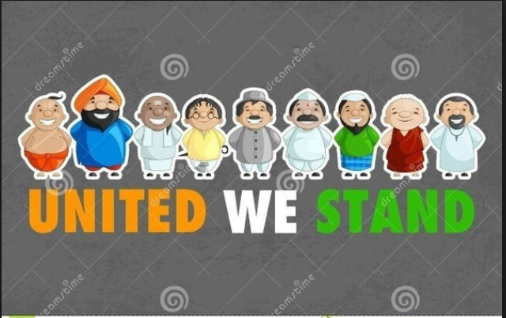

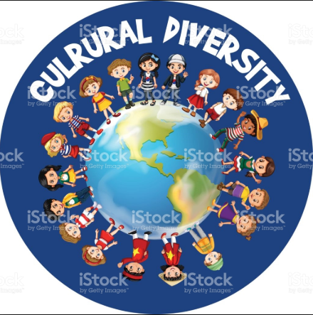

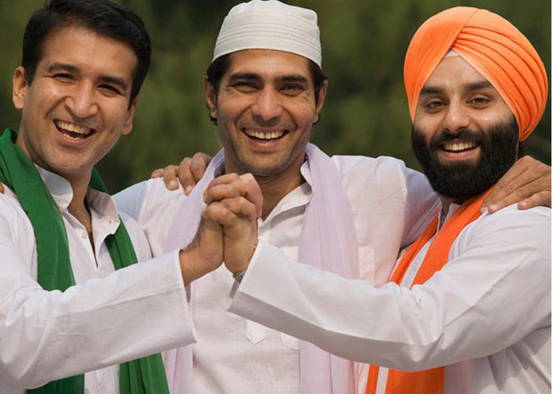 RELIGIOUS DIVERSITY

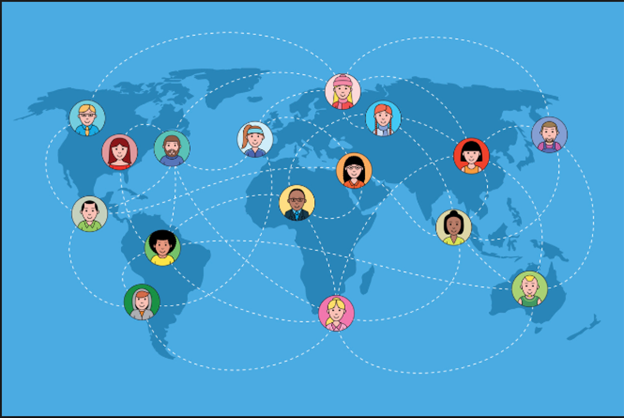LINGUISTIC DIVERSITY

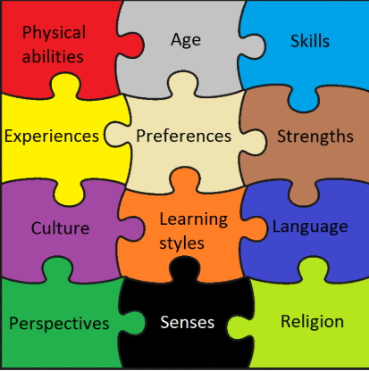

PSYCHOLOGICAL DIVERSITY



IDEOLOGICAL DIVERSITY

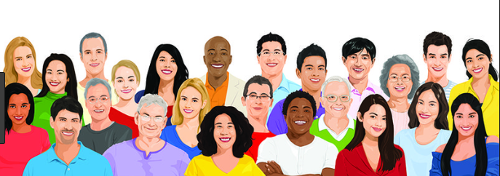

SOCIAL DIVERSITY